Moving Commands from One User Profile to Another
Moving commands from one user profile to another is a fairly simple process with any of the Dragon version above the premium (works for Professional, Legal and Medical). The process involves exporting the commands from one profile and importing them to another.
EXPORTING COMMANDS: Here’s the basic process, in this case illustrated with version 10 Medical, but similar in version 11 and 12:
- Open the Command Browser (either issue command “Open Command Browser” or navigate to Tools > Command Browser
- Be sure the Command Browser is expanded to show 3 full columns; if it isn’t, click on the “task pain” to expand it.
- Put the Command Browser into the “Manage” mode, either by clicking on the “Manage” area in the left column or navigating to Mode > Manage. You should see something looking like the image below, but with your own commands. Follow the listed steps.
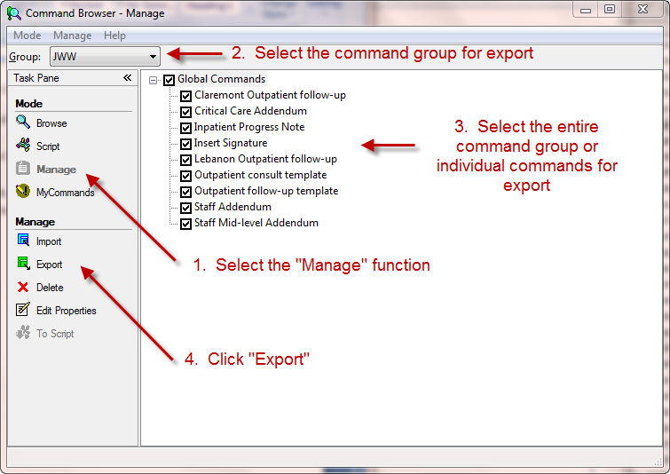
- Note: If you want to move ALL of your commands from one user profile to another, rather than selecting a single group from the “group” selection, select the “All” category. See below
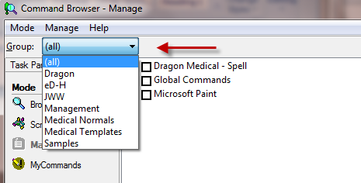
- Save the command group with any name you want and to any location you desire.
IMPORTING COMMANDS: This is basically the reverse of the exportation process and goes as follows:
- Switch to the user profile into which you want to import the commands
- Open the Command Browser (Tools > Command Browser)
- Open the “Manage” area.
- Click on “Import” button and follow instructions shown below:
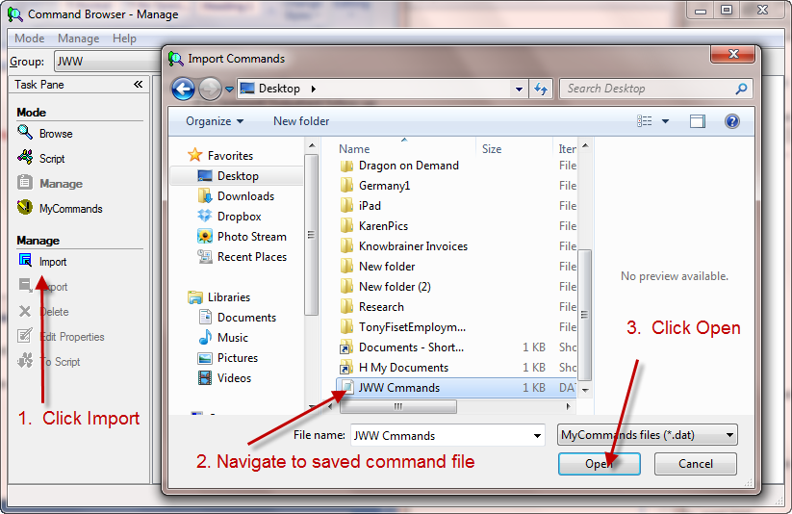
- On the Import Commands window that appears confirm the commands you want to import (uncheck any you don’t want to import) and click the import button. They will be instantly imported into you active profile.
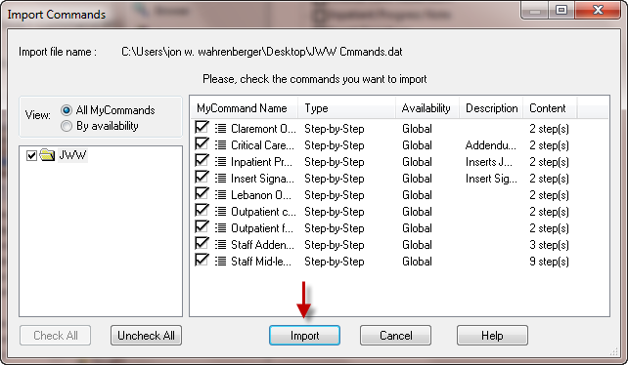

Copyright 2012, Speech Recognition Soltuions

